Ideation Phase
Define the Problem Statements

Date | 15 February 2026
Team ID | LTVIP2026TMIDS87366
Project Name | Prosperity Prognosticator: Machine Learning for Startup Success Prediction
Maximum Marks

Reference: https://miro.com/templates/customer-problem-statement/

Problem Statement (PS) | I am (Customer) | I’m trying to | But | Because | Which makes me feel
PS-1 | An investor or entrepreneur | Understand whether a startup has a high chance of success before investing or launching it | It is difficult to evaluate success based only on intuition or limited information | Startup performance depends on multiple factors such as funding, milestones, market conditions, and business relationships | Uncertain and hesitant about making investment or business decisions
PS-2 | A startup founder | Evaluate my startup’s growth potential and future success | I do not have a reliable system that can analyze historical data and predict outcomes | Manual analysis is complex and requires expert knowledge of data and market trends | Unsure about the direction and future of my startup

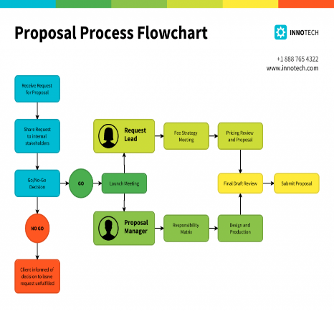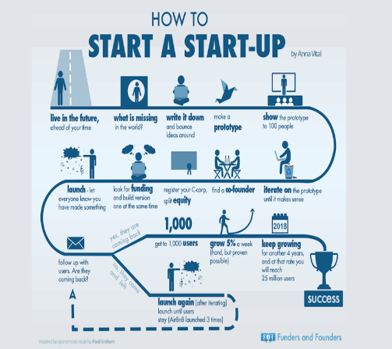

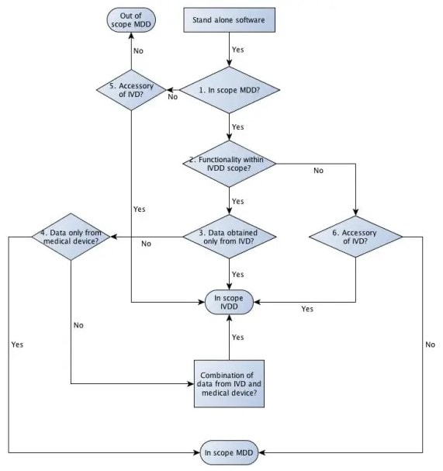

Figure: Problem–Solution Mapping for Startup Success Prediction System

